 |  | 

University of Debrecen
Faculty of Engineering
Department of Electrical Engineering and Mechatronics

Second homework

Modelling and simulation prototype technologies I.

2024/2025/I. semester
Title:
Quarter-Car Suspension: A Multi-Model Analysis

Created by:
Name: | Mohammed Mohammed Emad Said Soliman
Neptun: | UHCI4H
Department: | Mechatronics Engineer BSc.
Date: | 17/ 12 / 2025
Signature:

Introduction:

Vehicle suspension systems play a critical role in ensuring passenger comfort and maintaining adequate road holding. To analyze and improve suspension performance, simplified dynamic models are commonly used. One of the most widely adopted representations is the quarter-car model, which captures the vertical dynamics of a single wheel and the corresponding portion of the vehicle body. Despite its simplicity, this model provides valuable insight into the interaction between the tire, suspension components, and the vehicle chassis when subjected to road disturbances.
In this work, a quarter-car suspension system is modeled using state-space representation. The system includes sprung and unsprung masses connected through a spring–damper suspension and a tire stiffness element, with the road displacement modeled as an external disturbance. The objectives of this study are to analyze the dynamic behavior of the uncontrolled system, design a state-feedback controller using pole placement to improve ride comfort, and develop a state observer to estimate unmeasured states when only the chassis displacement is available for measurement. MATLAB and Simulink are used to implement the controller and observer and to evaluate system performance under different input conditions.

The system:

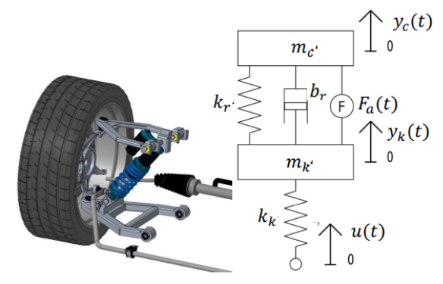
The system is a quarter car model, representing one corner of a vehicle. It consists of two main masses: the sprung mass (chassis) and unsprung mass (wheel assembly), connected by suspension components (spring and damper). The model analyzes how the system responds to road disturbances $u\left(t\right)$ and active control forces $F_{a}\left(t\right)$, with output focused on chassis displacement $y_{c}\left(t\right)$ for ride comfort assessment.

Equations of Motion:
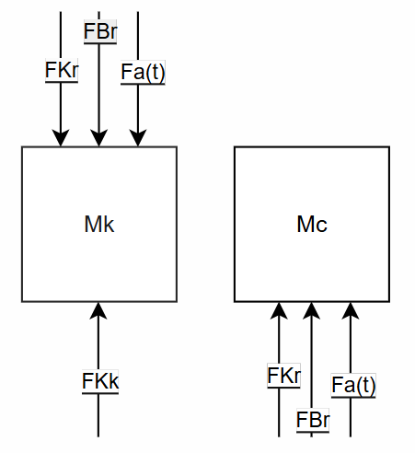
These equations of motion, derived from a free body diagram, describe the system dynamics. They balance inertial forces with spring, damper, and active forces, showing the coupled relationship between the wheel and chassis motions through the suspension elements.

𝑀𝑘 ∙ 𝑌𝑘̈ = 𝐹𝑘𝑘 − 𝐹𝑘𝑟 − 𝐹𝑏𝑟 − 𝐹𝑎(𝑡)
𝑀𝑐 ∙ 𝑌𝑐̈ = 𝐹𝑘𝑟 + 𝐹𝑏𝑟 + 𝐹𝑎(𝑡)
𝑌𝑘̈ =$\frac{Kk\left(U\left(t\right)- Yk\right)Mk – Kr\left(Yk – Yc\right)}{Mk}$ – $\frac{br\left(Y\dot{k}- Y\dot{c}\right) }{Mk}$ − $\frac{Fa\left(t\right) }{Mk}$
𝑌𝑐̈ = $\frac{Kr\left(Yk – Yc\right) }{Mc}$ + $\frac{br\left(Y\dot{k}- Y\dot{c}\right)Mc }{Mc}$ + $\frac{Fa\left(t\right) }{Mc}$

State soace representation :

𝑠𝑡𝑎𝑡𝑒 𝑣𝑎𝑟𝑖𝑎𝑏𝑙𝑒𝑠: 𝑌𝑘 = 𝑥1 𝑌𝑘̇ = 𝑥2 𝑌𝑐 = 𝑥3 𝑌𝑐̇ = 𝑥4

State space equation: $\frac{d}{dt}\left[\begin{aligned}X1 \\ X2 \\ X3 \\ X4\end{aligned}\right]= \left[\begin{matrix}\begin{matrix}\begin{matrix}\begin{matrix}0 \\ \frac{-k2-kr}{mk} \\ 0\end{matrix} & \begin{matrix}1 \\ \frac{-br}{mk} \\ 0\end{matrix} & \begin{matrix}0 \\ \frac{kr}{mk} \\ 0\end{matrix}\end{matrix} & \begin{matrix}0 \\ \frac{br}{mk} \\ 1\end{matrix}\end{matrix} \\ \begin{matrix}\begin{matrix}\frac{kr}{mc} & \frac{br}{mc} & \frac{-kr}{mc}\end{matrix} & \frac{-br}{mc}\end{matrix}\end{matrix}\right]. \left[\begin{aligned}X1 \\ X2 \\ X3 \\ X4\end{aligned}\right]+mc\left[\begin{matrix}\begin{matrix}0 \\ \frac{-1}{mk} \\ 0\end{matrix} & \begin{matrix}0 \\ \frac{Kk}{mk} \\ 0\end{matrix} \\ \frac{1}{mc} & 0\end{matrix}\right].\left[\begin{matrix}Fa\left(t\right) \\ u\left(t\right)\end{matrix}\right]$

Output equation: $y= \left[\begin{matrix} 0 & \begin{matrix}0 & 1 & 0\end{matrix}\end{matrix}\right]. \left[\begin{aligned}X1 \\ X2 \\ X3 \\ X4\end{aligned}\right]+0. u\left(t\right)$

Controllability and observabilityof the system :

For the original system :

Controllability matrix is calculated in matlab through the command Mc_orig = ctrb(A4, B1st) as following
$$Mc=\left[\begin{matrix}B & AB & \begin{matrix}A^{2}B & A^{3}B\end{matrix}\end{matrix}\right]$$

We have A= $\left[\begin{matrix}\begin{matrix}\begin{matrix}\begin{matrix}0 \\ \frac{-k2-kr}{mk} \\ 0\end{matrix} & \begin{matrix}1 \\ \frac{-br}{mk} \\ 0\end{matrix} & \begin{matrix}0 \\ \frac{kr}{mk} \\ 0\end{matrix}\end{matrix} & \begin{matrix}0 \\ \frac{br}{mk} \\ 1\end{matrix}\end{matrix} \\ \begin{matrix}\begin{matrix}\frac{kr}{mc} & \frac{br}{mc} & \frac{-kr}{mc}\end{matrix} & \frac{-br}{mc}\end{matrix}\end{matrix}\right] \& B= \left[\begin{matrix}\begin{matrix}0 \\ \frac{-1}{mk} \\ 0\end{matrix} & \begin{matrix}0 \\ \frac{Kk}{mk} \\ 0\end{matrix} \\ \frac{1}{mc} & 0\end{matrix}\right]$

$Mc= 1.0e+09\left[\begin{matrix}\begin{matrix}0.0000 & 0.0000 & \begin{matrix}-0.0002 & -0.0468\end{matrix}\end{matrix} \\ \begin{matrix}0.0000 & -0.0002 & \begin{matrix}-0.0468 & 3.0306\end{matrix}\end{matrix} \\ \begin{matrix}\begin{matrix}0.0000 & 0.0000 & \begin{matrix}0.0000 & -0.0003\end{matrix}\end{matrix} \\ \begin{matrix}0.0000 & 0.0000 & \begin{matrix}-0.0003 & -0.1827\end{matrix}\end{matrix}\end{matrix}\end{matrix}\right]$

The rank of Mc is 4 thus showing that The system is controllable as also approved through the matab code.

For the observability matrix of the original system , we have the following calculation as calculated in matlab through the order Mo_orig = obsv(A4, C4) :

$$Mc=\left[\begin{matrix}C & AC & \begin{matrix}A^{2}C & A^{3}C\end{matrix}\end{matrix}\right]$$

We have A= $\left[\begin{matrix}\begin{matrix}\begin{matrix}\begin{matrix}0 \\ \frac{-k2-kr}{mk} \\ 0\end{matrix} & \begin{matrix}1 \\ \frac{-br}{mk} \\ 0\end{matrix} & \begin{matrix}0 \\ \frac{kr}{mk} \\ 0\end{matrix}\end{matrix} & \begin{matrix}0 \\ \frac{br}{mk} \\ 1\end{matrix}\end{matrix} \\ \begin{matrix}\begin{matrix}\frac{kr}{mc} & \frac{br}{mc} & \frac{-kr}{mc}\end{matrix} & \frac{-br}{mc}\end{matrix}\end{matrix}\right] \& C=\left[\begin{matrix} 0 & \begin{matrix}0 & 1 & 0\end{matrix}\end{matrix}\right]$

$Mo= 1.0e+04\left[\begin{matrix}\begin{matrix}0.0000 & 0.0000 & \begin{matrix}0.0001 & 0.0000\end{matrix}\end{matrix} \\ \begin{matrix}0.0000 & 0.0000 & \begin{matrix}0.0000 & 0.0001\end{matrix}\end{matrix} \\ \begin{matrix}\begin{matrix}0.0074 & 0.0004 & \begin{matrix}-0.0074 & -0.0004\end{matrix}\end{matrix} \\ \begin{matrix}-2.7486 & -0.0046 & \begin{matrix}0.2469 & 0.0046\end{matrix}\end{matrix}\end{matrix}\end{matrix}\right]$

The rank of Mo is 4 thus showing that The system is observable as also approved through the matab code.

If Kr breaks :

The same calculations are done again only this time replacing the value of Kr to 0 as following :

$$Mc=\left[\begin{matrix}B & AB & \begin{matrix}A^{2}B & A^{3}B\end{matrix}\end{matrix}\right]$$

We have A= $\left[\begin{matrix}\begin{matrix}\begin{matrix}\begin{matrix}0 \\ \frac{-k2-0}{mk} \\ 0\end{matrix} & \begin{matrix}1 \\ \frac{-br}{mk} \\ 0\end{matrix} & \begin{matrix}0 \\ \frac{0}{mk} \\ 0\end{matrix}\end{matrix} & \begin{matrix}0 \\ \frac{br}{mk} \\ 1\end{matrix}\end{matrix} \\ \begin{matrix}\begin{matrix}\frac{0}{mc} & \frac{br}{mc} & \frac{0}{mc}\end{matrix} & \frac{-br}{mc}\end{matrix}\end{matrix}\right] \& B= \left[\begin{matrix}\begin{matrix}0 \\ \frac{-1}{mk} \\ 0\end{matrix} & \begin{matrix}0 \\ \frac{Kk}{mk} \\ 0\end{matrix} \\ \frac{1}{mc} & 0\end{matrix}\right]$

$$Mc= 1.0e+09\left[\begin{matrix}\begin{matrix}0.0000 & 0.0000 & \begin{matrix}-0.0002 & -0.0425\end{matrix}\end{matrix} \\ \begin{matrix}0.0000 & -0.0002 & \begin{matrix}-0.0425 & 2.7370\end{matrix}\end{matrix} \\ \begin{matrix}\begin{matrix}0.0000 & 0.0000 & \begin{matrix}0.0000 & -0.0008\end{matrix}\end{matrix} \\ \begin{matrix}0.0000 & 0.0000 & \begin{matrix}-0.0008 & -0.1479\end{matrix}\end{matrix}\end{matrix}\end{matrix}\right]$$

The rank of Mc is 3 thus showing that The system is not or just partly controllable as also approved through the matab code.

For the observability matrix we have :

$$Mc=\left[\begin{matrix}C & AC & \begin{matrix}A^{2}C & A^{3}C\end{matrix}\end{matrix}\right]$$

We have A= $\left[\begin{matrix}\begin{matrix}\begin{matrix}\begin{matrix}0 \\ \frac{-k2-0}{mk} \\ 0\end{matrix} & \begin{matrix}1 \\ \frac{-br}{mk} \\ 0\end{matrix} & \begin{matrix}0 \\ \frac{0}{mk} \\ 0\end{matrix}\end{matrix} & \begin{matrix}0 \\ \frac{br}{mk} \\ 1\end{matrix}\end{matrix} \\ \begin{matrix}\begin{matrix}\frac{0}{mc} & \frac{br}{mc} & \frac{0}{mc}\end{matrix} & \frac{-br}{mc}\end{matrix}\end{matrix}\right] \& C=\left[\begin{matrix} 0 & \begin{matrix}0 & 1 & 0\end{matrix}\end{matrix}\right]$

$$Mo= 1.0e+04\left[\begin{matrix}\begin{matrix}0.0000 & 0.0000 & \begin{matrix}0.0001 & 0.0000\end{matrix}\end{matrix} \\ \begin{matrix}0.0000 & 0.0000 & \begin{matrix}0.0000 & 0.0001\end{matrix}\end{matrix} \\ \begin{matrix}\begin{matrix}0.0074 & 0.0004 & \begin{matrix}0.0000 & -0.0004\end{matrix}\end{matrix} \\ \begin{matrix}-2.5017 & -0.0119 & \begin{matrix}0.0000 & 0.0119\end{matrix}\end{matrix}\end{matrix}\end{matrix}\right]$$

The rank of Mo is 4 thus showing that The system is observable as also approved through the matab code.

If Kk breaks and Br got stuck :

The same calculations are done again only this time replacing the value of Kk and Br to 0 as following :

$$Mc=\left[\begin{matrix}B & AB & \begin{matrix}A^{2}B & A^{3}B\end{matrix}\end{matrix}\right]$$

We have A=$\left[\begin{matrix}\begin{matrix}\begin{matrix}\begin{matrix}0 \\ \frac{0-kr}{mk} \\ 0\end{matrix} & \begin{matrix}1 \\ \frac{0}{mk} \\ 0\end{matrix} & \begin{matrix}0 \\ \frac{kr}{mk} \\ 0\end{matrix}\end{matrix} & \begin{matrix}0 \\ \frac{0}{mk} \\ 1\end{matrix}\end{matrix} \\ \begin{matrix}\begin{matrix}\frac{kr}{mc} & \frac{0}{mc} & \frac{-kr}{mc}\end{matrix} & \frac{0}{mc}\end{matrix}\end{matrix}\right] \& B= \left[\begin{matrix}\begin{matrix}0 \\ \frac{-1}{mk} \\ 0\end{matrix} & \begin{matrix}0 \\ \frac{0}{mk} \\ 0\end{matrix} \\ \frac{1}{mc} & 0\end{matrix}\right]$

$$Mc=\left[\begin{matrix}\begin{matrix}0.0000 & 0.0000 & \begin{matrix}0.0000 & 0.0000\end{matrix}\end{matrix} \\ \begin{matrix}0.0000 & 0.0000 & \begin{matrix}0.0000 & 0.0000\end{matrix}\end{matrix} \\ \begin{matrix}\begin{matrix}0.0000 & 0.0000 & \begin{matrix}0.0000 & 0.0000\end{matrix}\end{matrix} \\ \begin{matrix}0.0000 & 0.0000 & \begin{matrix}0.0000 & 0.0000\end{matrix}\end{matrix}\end{matrix}\end{matrix}\right]$$

The rank of Mc is 0 thus showing that The system is not or just partly controllable as also approved through the matab code.

For the observability matrix we have :

$$Mc=\left[\begin{matrix}C & AC & \begin{matrix}A^{2}C & A^{3}C\end{matrix}\end{matrix}\right]$$

We have A= $\left[\begin{matrix}\begin{matrix}\begin{matrix}\begin{matrix}0 \\ \frac{0-kr}{mk} \\ 0\end{matrix} & \begin{matrix}1 \\ \frac{0}{mk} \\ 0\end{matrix} & \begin{matrix}0 \\ \frac{kr}{mk} \\ 0\end{matrix}\end{matrix} & \begin{matrix}0 \\ \frac{0}{mk} \\ 1\end{matrix}\end{matrix} \\ \begin{matrix}\begin{matrix}\frac{kr}{mc} & \frac{0}{mc} & \frac{-kr}{mc}\end{matrix} & \frac{0}{mc}\end{matrix}\end{matrix}\right] \& C=\left[\begin{matrix} 0 & \begin{matrix}0 & 1 & 0\end{matrix}\end{matrix}\right]$

$$Mo= 1.0e+04\left[\begin{matrix}\begin{matrix}0.0000 & 0.0000 & \begin{matrix}1.0000 & 0.0000\end{matrix}\end{matrix} \\ \begin{matrix}0.0000 & 0.0000 & \begin{matrix}0.0000 & 1.0000 \end{matrix}\end{matrix} \\ \begin{matrix}\begin{matrix}73.5294 & 0.0000 & \begin{matrix}-73.5294 & 0.0000\end{matrix}\end{matrix} \\ \begin{matrix}0.0000 & 73.5294 & \begin{matrix}0.0000 & -73.5294\end{matrix}\end{matrix}\end{matrix}\end{matrix}\right]$$

The rank of Mo is 4 thus showing that The system is observable as also approved through the matab code.

The state feedback controller Design :

Poles of the original system :

To get the poles of the original system we follow the next steps :

First we get the characteristic equation of the polynomial following the next steps :

First we get the characteristic equation of the system from the following equation:

$$\det\left[ SI-A\right]$$

$$\det\left[\begin{matrix}\begin{matrix}S \\ 0 \\ 0\end{matrix} & \begin{matrix}\begin{matrix}0 & 0 & 0\end{matrix} \\ \begin{matrix}S & 0 & 0\end{matrix} \\ \begin{matrix}0 & S & 0\end{matrix}\end{matrix} \\ 0 & \begin{matrix}0 & 0 & S\end{matrix}\end{matrix}\right]- \left[\begin{matrix}\begin{matrix}\begin{matrix}\begin{matrix}0 \\ \frac{-k2-kr}{mk} \\ 0\end{matrix} & \begin{matrix}1 \\ \frac{-br}{mk} \\ 0\end{matrix} & \begin{matrix}0 \\ \frac{kr}{mk} \\ 0\end{matrix}\end{matrix} & \begin{matrix}0 \\ \frac{br}{mk} \\ 1\end{matrix}\end{matrix} \\ \begin{matrix}\begin{matrix}\frac{kr}{mc} & \frac{br}{mc} & \frac{-kr}{mc}\end{matrix} & \frac{-br}{mc}\end{matrix}\end{matrix}\right]$$

$$s4+33.57s3+7733.98s2+25017.25s+517598.34$$

Then we solve for the roots of the equation
$$s4+33.57s3+7733.98s2+25017.25s+517598.34=0$$

$$original_{poles}=$$
- $-15.2734 +85.6731i$
- $-15.2734 -85.6731i$
- $-1.5139 + 8.1274i$
- $-1.5139 - 8.1274i$

We can validate this by using the command original_poles = eig(A_orig) on matlab.

The new desired Poles:

The poles of the original system include imajinary parts which indicates that the system will have oscilation and overshooting which causes discomfort for the passengers , thus we need to change the poles of the system to be only negative real parts in order to have a stable system .

The chosen new desired poles are :

- p1 = -50
- p2 = -50
- p3 = -5
- p4 = -5
- desired_poles = [p1 p2 p3 p4]

Kt calculations using achraman formula

Following the next steps we can calculate the K^{t} using achraman formula :

$$K^{T}=\left[\begin{matrix}0 & \begin{matrix}0 & 0 & 1\end{matrix}\end{matrix}​\right] {Mc}^{-1}​α\left(A\right)$$

We have
$${Mc}^{-1}=\frac{adj\left(Mc​\right)​}{\det\left(Mc​\right)} = \left[\begin{matrix}\begin{matrix}-0.0400 & 0.0001 \\ 0.0025 & 0.0000\end{matrix} & \begin{matrix}0.0884 & 0.0125 \\ 0.0125 & -0.0007\end{matrix} \\ \begin{matrix}0.0000 & 0.0000 \\ 0.0000 & 0.0000\end{matrix} & \begin{matrix}0.0001 & 0.0000 \\ 0.0000 & 0.0000\end{matrix}\end{matrix}\right]$$

And we have

$$​α\left(A\right)=A4+​α3A^{3}+​α2A^{2}+​α1 A+​α0 I$$

$$= 1.0e+09 \left[\begin{matrix}\begin{matrix}0.0495 & -0.0004 \\ 2.8963 & 0.0604\end{matrix} & \begin{matrix}-0.0042 & -0.0002 \\ -0.2243 & -0.0150\end{matrix} \\ \begin{matrix}-0.0024 & 0.0000 \\ 0.1429 & -0.0018\end{matrix} & \begin{matrix}0.0000 & 0.0000 \\ -0.0130 & -0.0006\end{matrix}\end{matrix}\right]$$

Then we can calculate

$$K^{T}=\left[\begin{matrix}0 & \begin{matrix}0 & 0 & 1\end{matrix}\end{matrix}​\right] \left[\begin{matrix}\begin{matrix}-0.0400 & 0.0001 \\ 0.0025 & 0.0000\end{matrix} & \begin{matrix}0.0884 & 0.0125 \\ 0.0125 & -0.0007\end{matrix} \\ \begin{matrix}0.0000 & 0.0000 \\ 0.0000 & 0.0000\end{matrix} & \begin{matrix}0.0001 & 0.0000 \\ 0.0000 & 0.0000\end{matrix}\end{matrix}\right]*\left(1.0e+09 \left[\begin{matrix}\begin{matrix}0.0495 & -0.0004 \\ 2.8963 & 0.0604\end{matrix} & \begin{matrix}-0.0042 & -0.0002 \\ -0.2243 & -0.0150\end{matrix} \\ \begin{matrix}-0.0024 & 0.0000 \\ 0.1429 & -0.0018\end{matrix} & \begin{matrix}0.0000 & 0.0000 \\ -0.0130 & -0.0006\end{matrix}\end{matrix}\right]\right)$$

$$= \left[\begin{matrix}-0.7660 & 0.0109 & \begin{matrix}-0.1132 & 0.0364\end{matrix}\end{matrix}\right]$$

We can also calculate it on MATLAB using the command KT = acker(A4 ,B1st ,desired poles) and after comparing both results we have the same matrix for Kt and Kt2 thus our calculations are correct.

Results:

Using this Simulink model with a step signal as an input, the following results are obtained.
The uncontrolled system exhibits a highly oscillatory response with a large overshoot immediately after the step input is applied. This behavior indicates poor damping and slow attenuation of vibrations, which is undesirable from a ride-comfort perspective. Although the uncontrolled response eventually converges to the steady-state value, the transient behavior is dominated by oscillations and peak amplitudes that may negatively affect passenger comfort and component longevity.
In contrast, the controlled system demonstrates a significantly improved response. The application of state-feedback control reduces overshoot and suppresses oscillations, resulting in a smoother transient and faster convergence toward the steady-state value. The controlled response closely follows the input with improved stability and reduced settling time compared to the uncontrolled case. These results confirm that the designed controller effectively enhances the dynamic performance of the suspension system by increasing damping and mitigating the adverse effects of road disturbances.
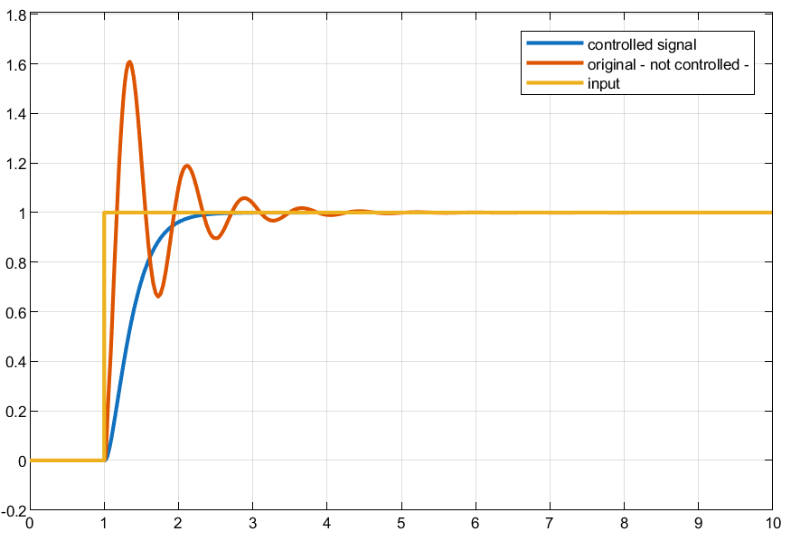
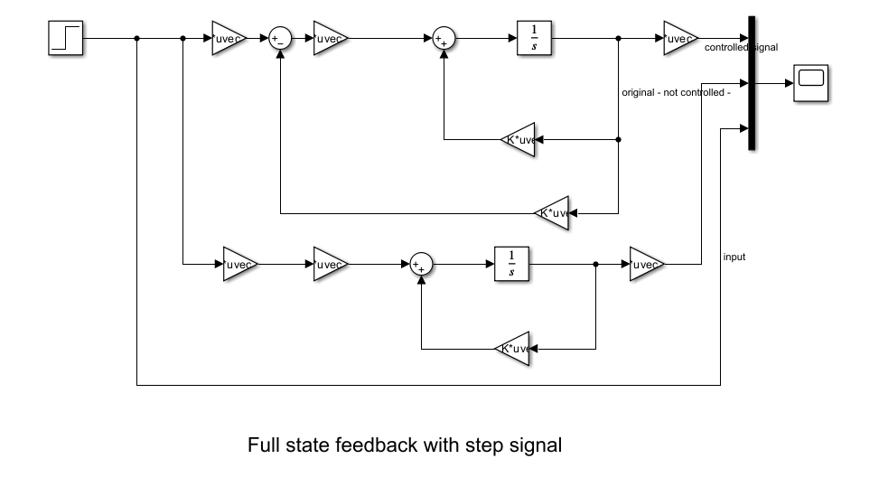

Using the following Simulink circuit with a ramp input and two different parameter sets, the following results are obtained.
For both parameter configurations, the uncontrolled system exhibits a pronounced transient response characterized by higher peak values and noticeable oscillations before settling. This behavior indicates limited damping and reduced ability to attenuate road-induced disturbances, particularly during changes in the road profile represented by the ramp input.

When the state-feedback controller is applied, the system response improves significantly in both cases. The controlled output shows reduced peak amplitude, smoother transient behavior, and faster attenuation of oscillations compared to the uncontrolled system. Although slight deviations from the input remain during the transient phase, the controlled response consistently demonstrates improved stability and reduced vibration levels.

Comparing the two parameter sets, differences in peak magnitude and transient duration are observed, reflecting the influence of suspension stiffness and damping on system dynamics. Nevertheless, in both cases, the controller effectively mitigates the adverse effects of the ramp input, confirming its robustness to parameter variations and its ability to enhance ride comfort under changing road conditions.

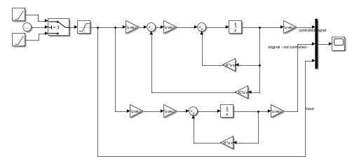

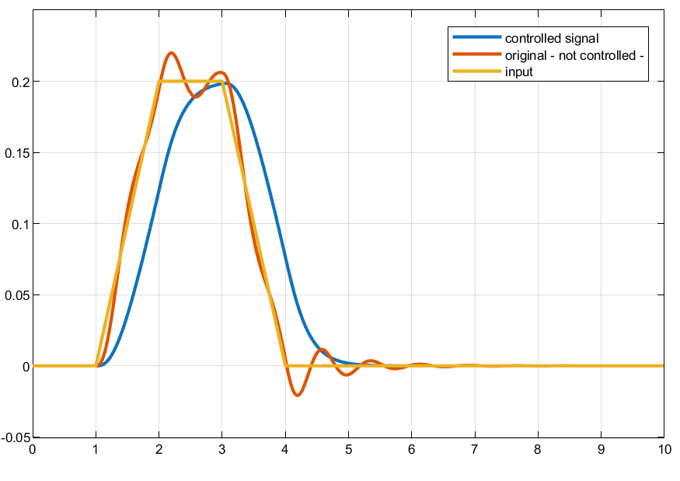
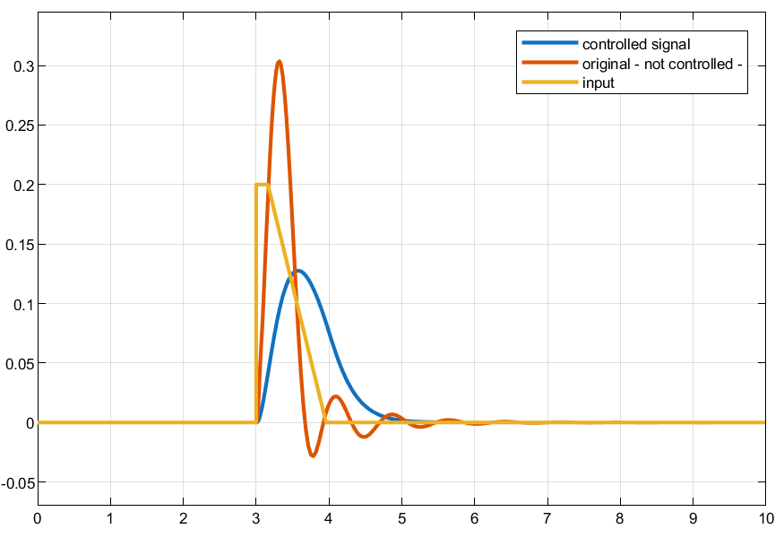

State observer calculations:

For the state observer, first we need to calculate the control canonical forms of the original system:

𝜏= $\left[\begin{matrix}\begin{matrix} 1 & a3 \\ 0 & 1\end{matrix} & \begin{matrix}a2 & a1 \\ a3 & a2\end{matrix} \\ \begin{matrix}0 & 0 \\ 0 & 0\end{matrix} & \begin{matrix}1 & a3 \\ 0 & 1\end{matrix}\end{matrix}\right]$= $1.0e+04*\left[\begin{matrix}\begin{matrix}0.0001 & 0.0034 \\ 0 & 0.0001\end{matrix} & \begin{matrix}0.7734 & 2.5017 \\ 0.0034 & 0.7734\end{matrix} \\ \begin{matrix}0 & 0 \\ 0 & 0\end{matrix} & \begin{matrix}0.0001 & 0.0034 \\ 0 & 0.0001\end{matrix}\end{matrix}\right]$

$$T^{-1}=Mc\left(A,B\right)* t\left(a\right)$$

$$T^{-1}= 1.0e+09\left[\begin{matrix}\begin{matrix}0.0000 & 0.0000 & \begin{matrix}-0.0002 & -0.0425\end{matrix}\end{matrix} \\ \begin{matrix}0.0000 & -0.0002 & \begin{matrix}-0.0425 & 2.7370\end{matrix}\end{matrix} \\ \begin{matrix}\begin{matrix}0.0000 & 0.0000 & \begin{matrix}0.0000 & -0.0008\end{matrix}\end{matrix} \\ \begin{matrix}0.0000 & 0.0000 & \begin{matrix}-0.0008 & -0.1479\end{matrix}\end{matrix}\end{matrix}\end{matrix}\right]* 1.0e+04*\left[\begin{matrix}\begin{matrix}0.0001 & 0.0034 \\ 0 & 0.0001\end{matrix} & \begin{matrix}0.7734 & 2.5017 \\ 0.0034 & 0.7734\end{matrix} \\ \begin{matrix}0 & 0 \\ 0 & 0\end{matrix} & \begin{matrix}0.0001 & 0.0034 \\ 0 & 0.0001\end{matrix}\end{matrix}\right]$$

$$T^{-1}= 1.0e+05\left[\begin{matrix}\begin{matrix}0.0000 & 0.0704 & \begin{matrix}0.2502 & 5.1760\end{matrix}\end{matrix} \\ \begin{matrix}0.0704 & 0.2502 & \begin{matrix}5.1760 & 0.0000\end{matrix}\end{matrix} \\ \begin{matrix}\begin{matrix}0.0000 & 0.0000 & \begin{matrix}0.2502 & 5.1760\end{matrix}\end{matrix} \\ \begin{matrix}0.0000 & 0.2502 & \begin{matrix}5.1760 & 0.0000\end{matrix}\end{matrix}\end{matrix}\end{matrix}\right]$$

$$T={[T^{-1}]}^{-1 }= 1.0-03\left[\begin{matrix}\begin{matrix}0.0000 & 0.1421 & \begin{matrix}0.0000 & -0.1421\end{matrix}\end{matrix} \\ \begin{matrix}0.1421 & 0.0000 & \begin{matrix}-0.1421 & 0.0000\end{matrix}\end{matrix} \\ \begin{matrix}\begin{matrix}-0.0069 & 0.0000 & \begin{matrix}0.0069 & 0.0019\end{matrix}\end{matrix} \\ \begin{matrix}0.0003 & 0.0000 & \begin{matrix}0.0016 & -0.0001\end{matrix}\end{matrix}\end{matrix}\end{matrix}\right]$$

$$Ac=T*A*T^{-1}$$

$$Ac= 1.0-03\left[\begin{matrix}\begin{matrix}0.0000 & 0.1421 & \begin{matrix}0.0000 & -0.1421\end{matrix}\end{matrix} \\ \begin{matrix}0.1421 & 0.0000 & \begin{matrix}-0.1421 & 0.0000\end{matrix}\end{matrix} \\ \begin{matrix}\begin{matrix}-0.0069 & 0.0000 & \begin{matrix}0.0069 & 0.0019\end{matrix}\end{matrix} \\ \begin{matrix}0.0003 & 0.0000 & \begin{matrix}0.0016 & -0.0001\end{matrix}\end{matrix}\end{matrix}\end{matrix}\right]* \left[\begin{matrix}\begin{matrix}\begin{matrix}\begin{matrix}0 \\ \frac{-k2-kr}{mk} \\ 0\end{matrix} & \begin{matrix}1 \\ \frac{-br}{mk} \\ 0\end{matrix} & \begin{matrix}0 \\ \frac{kr}{mk} \\ 0\end{matrix}\end{matrix} & \begin{matrix}0 \\ \frac{br}{mk} \\ 1\end{matrix}\end{matrix} \\ \begin{matrix}\begin{matrix}\frac{kr}{mc} & \frac{br}{mc} & \frac{-kr}{mc}\end{matrix} & \frac{-br}{mc}\end{matrix}\end{matrix}\right]* 1.0e+05\left[\begin{matrix}\begin{matrix}0.0000 & 0.0704 & \begin{matrix}0.2502 & 5.1760\end{matrix}\end{matrix} \\ \begin{matrix}0.0704 & 0.2502 & \begin{matrix}5.1760 & 0.0000\end{matrix}\end{matrix} \\ \begin{matrix}\begin{matrix}0.0000 & 0.0000 & \begin{matrix}0.2502 & 5.1760\end{matrix}\end{matrix} \\ \begin{matrix}0.0000 & 0.2502 & \begin{matrix}5.1760 & 0.0000\end{matrix}\end{matrix}\end{matrix}\end{matrix}\right]$$

$$Ac= \left[\begin{matrix}\begin{matrix}\begin{matrix}\begin{matrix}-0.0003 \\ 0.0000 \\ 0.0000\end{matrix} & \begin{matrix}-0.0773 \\ 0.0000 \\ 0.0000\end{matrix} & \begin{matrix}-0.2502 \\ 0.0000 \\ 0.0000\end{matrix}\end{matrix} & \begin{matrix}-5.1760 \\ 0.0000 \\ 0.0000\end{matrix}\end{matrix} \\ \begin{matrix}\begin{matrix}0.0000 & 0.0000 & 0.0000\end{matrix} & 0.0000\end{matrix}\end{matrix}\right]$$

$$bc=T*b= 1.0-03\left[\begin{matrix}\begin{matrix}0.0000 & 0.1421 & \begin{matrix}0.0000 & -0.1421\end{matrix}\end{matrix} \\ \begin{matrix}0.1421 & 0.0000 & \begin{matrix}-0.1421 & 0.0000\end{matrix}\end{matrix} \\ \begin{matrix}\begin{matrix}-0.0069 & 0.0000 & \begin{matrix}0.0069 & 0.0019\end{matrix}\end{matrix} \\ \begin{matrix}0.0003 & 0.0000 & \begin{matrix}0.0016 & -0.0001\end{matrix}\end{matrix}\end{matrix}\end{matrix}\right]* \left[\begin{matrix}\begin{matrix}0 \\ \frac{-1}{mk} \\ 0\end{matrix} & \begin{matrix}0 \\ \frac{0}{mk} \\ 0\end{matrix} \\ \frac{1}{mc} & 0\end{matrix}\right]$$

$$bc= \left[\begin{matrix}1 \\ 0 \\ \begin{matrix}0 \\ 0\end{matrix}\end{matrix}\right]$$

$${Cc}^{t}= C^{t}* T^{-1}= \left[\begin{matrix} 0 & \begin{matrix}0 & 1 & 0\end{matrix}\end{matrix}\right]. 1.0e+05\left[\begin{matrix}\begin{matrix}0.0000 & 0.0704 & \begin{matrix}0.2502 & 5.1760\end{matrix}\end{matrix} \\ \begin{matrix}0.0704 & 0.2502 & \begin{matrix}5.1760 & 0.0000\end{matrix}\end{matrix} \\ \begin{matrix}\begin{matrix}0.0000 & 0.0000 & \begin{matrix}0.2502 & 5.1760\end{matrix}\end{matrix} \\ \begin{matrix}0.0000 & 0.2502 & \begin{matrix}5.1760 & 0.0000\end{matrix}\end{matrix}\end{matrix}\end{matrix}\right]$$

$${Cc}^{t}= 1.0e+05 \left[\begin{matrix} 0 & \begin{matrix}0 & 0.2502 & 5.1760\end{matrix}\end{matrix}\right]$$

We can now get A_{0 ,} B₀ and C₀ from $Ac , bc ,$ ${Cc}^{t}$

$$A0= {Ac}^{T}= \left[\begin{matrix}\begin{matrix}\begin{matrix}\begin{matrix}-0.0003 \\ -0.0773 \\ -0.2502\end{matrix} & \begin{matrix}0.0000 \\ 0.0000 \\ 0.0000\end{matrix} & \begin{matrix}0.0000 \\ 0.0000 \\ 0.0000\end{matrix}\end{matrix} & \begin{matrix}0.0000 \\ 0.0000 \\ 0.0000\end{matrix}\end{matrix} \\ \begin{matrix}\begin{matrix}-5.1760 & 0.0000 & 0.0000\end{matrix} & 0.0000\end{matrix}\end{matrix}\right]$$

$b0=Cc= 1.0e+05\left[\begin{matrix}\begin{matrix}0 \\ 0\end{matrix} \\ 0.2502 \\ 5.1760\end{matrix}\right]$

$${C0}^{t}=bc= \left[\begin{matrix}1 & \begin{matrix}0 & 0 & 0\end{matrix}\end{matrix}\right]$$

New desired poles for the observer :

- p1 = -80
- p2 = -80
- p3 = -25
- p4 = -25
- desired_poles = [p1 p2 p3 p4]

α(s)=(s+80)2(s+25)2=s4+210s3+15025s2+420000s+4000000

α3​=210, α2​=15025, α1​=420000, α0​=4000000

l00​ = α0​−a0​ = 3.4824e+06​
l10​ = α1​−a1​ = 3.9498e+05​
l20 = α2−a2 = 7.2910e+03​
l30​ = α3−a3​ = 176.4254

$${{ K0}^{T}= l0}^{T}= 1.0e+06 * \left[\begin{matrix}0.0002 & \begin{matrix}0.0073 & 0.3950 & 3.4824\end{matrix}\end{matrix}\right]$$

$${ Kc}^{T}= { K0}^{T}*T$$

$${ Kc}^{T}= 1.0e+06 * \left[\begin{matrix}0.0002 & \begin{matrix}0.0073 & 0.3950 & 3.4824\end{matrix}\end{matrix}\right]* 1.0-03\left[\begin{matrix}\begin{matrix}0.0000 & 0.1421 & \begin{matrix}0.0000 & -0.1421\end{matrix}\end{matrix} \\ \begin{matrix}0.1421 & 0.0000 & \begin{matrix}-0.1421 & 0.0000\end{matrix}\end{matrix} \\ \begin{matrix}\begin{matrix}-0.0069 & 0.0000 & \begin{matrix}0.0069 & 0.0019\end{matrix}\end{matrix} \\ \begin{matrix}0.0003 & 0.0000 & \begin{matrix}0.0016 & -0.0001\end{matrix}\end{matrix}\end{matrix}\end{matrix}\right]$$
​
${ Kc}^{T}=1.0e+05 * \left[\begin{matrix}-0.0035 & \begin{matrix}-2.7350 & 0.0018\end{matrix} & 0.0137\end{matrix}\right]$​

Kc = Lc = $\left[\begin{matrix}-0.0035 \\ \begin{matrix}-2.7350 \\ 0.0018\end{matrix} \\ 0.0137\end{matrix}\right]$

Using the following Simulink circuit for the state observer, the obtained results are shown in the figure.
The comparison between the actual system output and the observer-estimated output indicates that the state observer successfully reconstructs the system behavior using the available measured signal. After a short transient period, the observer output closely follows the true system response, demonstrating satisfactory convergence of the estimation error.
During the initial transient, a small mismatch between the system and observer responses is observed, which is expected due to the chosen observer dynamics and the absence of exact initial state matching. However, this error decays rapidly, and the observer output converges to the system output without introducing sustained oscillations or instability. The close agreement between the two signals in steady state confirms that the system is observable and that the selected observer poles provide sufficiently fast estimation dynamics.
Overall, the results validate the effectiveness of the designed state observer in accurately estimating the system states, making it suitable for use in observer-based state-feedback control implementations.
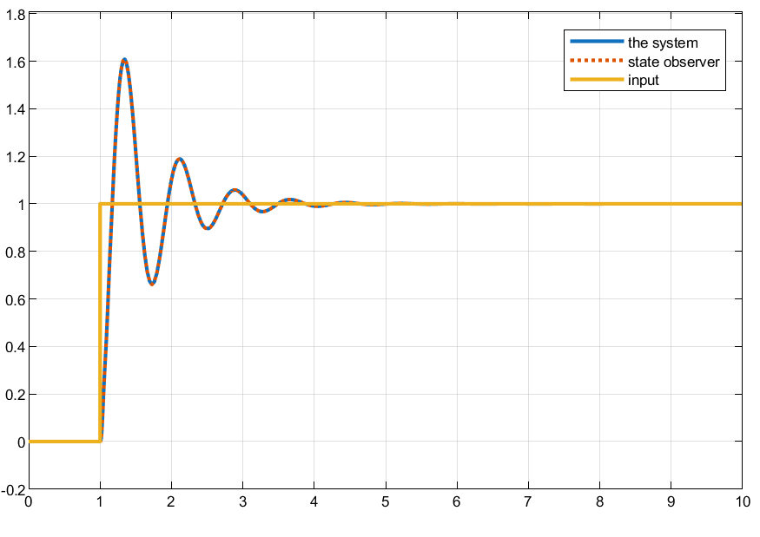
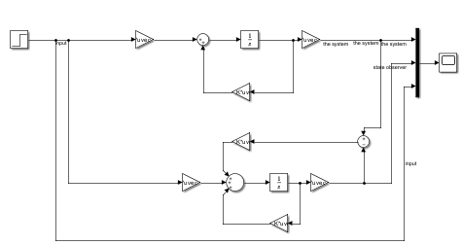

Conclusion

In this report, a quarter-car suspension system was modeled and analyzed using a state-space approach to investigate its dynamic behavior and to evaluate the effectiveness of active control and state estimation techniques. The original system exhibited oscillatory responses and slow attenuation of vibrations when subjected to road disturbances, highlighting the limitations of passive suspension dynamics in achieving satisfactory ride comfort.
A state-feedback controller was designed using pole placement to improve system stability and transient performance. Simulation results demonstrated that the controlled system achieved reduced oscillations, lower overshoot, and faster settling times compared to the uncontrolled case. These improvements confirm that appropriate pole selection can effectively separate and damp both the fast wheel-hop dynamics and the slower body motion, resulting in enhanced ride comfort and improved dynamic response.
To address the limitation of unmeasured states, a state observer was developed to estimate the full system state using only the measured chassis displacement. The observer showed rapid convergence and accurate state reconstruction, validating the observability of the system and the suitability of the chosen observer poles. The observer-based implementation further demonstrated that state feedback can be successfully applied even when full state measurements are not available.
Overall, the combination of state-feedback control and state observation provides a robust framework for improving suspension performance. The study also highlights important practical considerations, such as numerical scaling, pole placement trade-offs, and the need for reference tracking or integral action when nonzero steady-state outputs are required. Future work may focus on incorporating integral control for improved disturbance rejection, optimizing controller performance using LQR/LQI methods, and evaluating robustness under parameter uncertainty and measurement noise.

